Cisco Packet Tracer DHCP Relay project
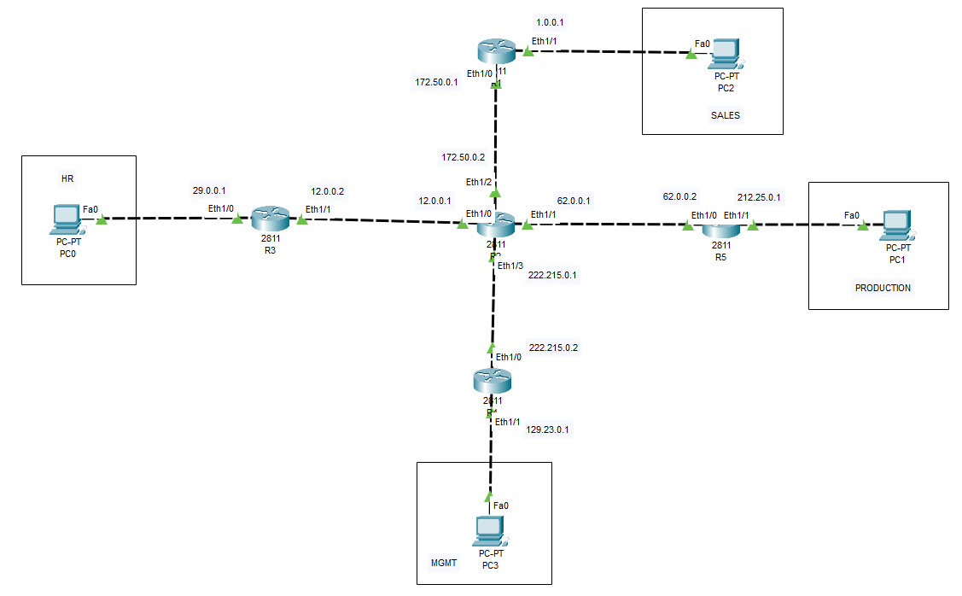

Phase 1: Configure IP Addresses on All Router Interfaces
R1
conf t
int eth1/0
ip address 172.50.0.1 255.255.255.0
no shut

int eth1/1
ip address 1.0.0.1 255.255.255.0
no shut
R2
conf t
int eth1/0
ip address 12.0.0.1 255.255.255.0
no shut

int eth1/1
ip address 62.0.0.1 255.255.255.0
no shut

int eth1/2
ip address 172.50.0.2 255.255.255.0
no shut

int eth1/3
ip address 222.215.0.1 255.255.255.0
no shut
R3
conf t
int eth1/0
ip address 29.0.0.1 255.255.255.0
no shut

int eth1/1
ip address 12.0.0.2 255.255.255.0
no shut
R4
conf t
int eth1/0
ip address 222.215.0.2 255.255.255.0
no shut

int eth1/1
ip address 129.23.0.1 255.255.255.0
no shut
R5
conf t
int eth1/0
ip address 62.0.0.2 255.255.255.0
no shut

int eth1/1
ip address 212.25.0.1 255.255.255.0
no shut

Phase 2: Verify Directly Connected Networks
On each router:
show ip interface brief
show ip route
You should see only C (Connected) routes.
Example on R1:
R1#show ip route

C 172.50.0.0/24 is directly connected, Eth1/0
C 1.0.0.0/24 is directly connected, Eth1/1

Phase 3: Configure Static Routes
R1
ip route 29.0.0.0 255.255.255.0 172.50.0.2
ip route 129.23.0.0 255.255.255.0 172.50.0.2
ip route 212.25.0.0 255.255.255.0 172.50.0.2
R3
ip route 1.0.0.0 255.255.255.0 12.0.0.1
ip route 129.23.0.0 255.255.255.0 12.0.0.1
ip route 212.25.0.0 255.255.255.0 12.0.0.1
R4
ip route 1.0.0.0 255.255.255.0 222.215.0.1
ip route 29.0.0.0 255.255.255.0 222.215.0.1
ip route 212.25.0.0 255.255.255.0 222.215.0.1
R5
ip route 1.0.0.0 255.255.255.0 62.0.0.1
ip route 29.0.0.0 255.255.255.0 62.0.0.1
ip route 129.23.0.0 255.255.255.0 62.0.0.1
R2 (Core Router)
ip route 1.0.0.0 255.255.255.0 172.50.0.1
ip route 29.0.0.0 255.255.255.0 12.0.0.2
ip route 129.23.0.0 255.255.255.0 222.215.0.2
ip route 212.25.0.0 255.255.255.0 62.0.0.2

Phase 4: Test Routing Before DHCP
Assign temporary static IPs to the PCs:
PC0 (HR)
IP: 29.0.0.10
Mask: 255.255.255.0
Gateway: 29.0.0.1
PC1 (PRODUCTION)
IP: 212.25.0.10
Mask: 255.255.255.0
Gateway: 212.25.0.1
PC2 (SALES)
IP: 1.0.0.10
Mask: 255.255.255.0
Gateway: 1.0.0.1
PC3 (MGMT)
IP: 129.23.0.10
Mask: 255.255.255.0
Gateway: 129.23.0.1
Now test:
PC0 > ping 1.0.0.10
PC0 > ping 212.25.0.10
PC0 > ping 129.23.0.10
All pings should succeed.

Phase 5 – Configure DHCP Server on R2 and DHCP Relay
Once all PCs can ping each other using static IP addresses, proceed with DHCP.

Step 1: Configure R2 as DHCP Server
Exclude Gateway Addresses
R2(config)#ip dhcp excluded-address 1.0.0.1
R2(config)#ip dhcp excluded-address 29.0.0.1
R2(config)#ip dhcp excluded-address 129.23.0.1
R2(config)#ip dhcp excluded-address 212.25.0.1

Step 2: Create DHCP Pool for SALES Network
Network: 1.0.0.0/24
R2(config)#ip dhcp pool SALES

R2(dhcp-config)#network 1.0.0.0 255.255.255.0

R2(dhcp-config)#default-router 1.0.0.1

R2(dhcp-config)#dns-server 8.8.8.8

R2(dhcp-config)#exit

Step 3: Create DHCP Pool for HR Network
Network: 29.0.0.0/24
R2(config)#ip dhcp pool HR

R2(dhcp-config)#network 29.0.0.0 255.255.255.0

R2(dhcp-config)#default-router 29.0.0.1

R2(dhcp-config)#dns-server 8.8.8.8

R2(dhcp-config)#exit

Step 4: Create DHCP Pool for MGMT Network
Network: 129.23.0.0/24
R2(config)#ip dhcp pool MGMT

R2(dhcp-config)#network 129.23.0.0 255.255.255.0

R2(dhcp-config)#default-router 129.23.0.1

R2(dhcp-config)#dns-server 8.8.8.8

R2(dhcp-config)#exit

Step 5: Create DHCP Pool for PRODUCTION Network
Network: 212.25.0.0/24
R2(config)#ip dhcp pool PRODUCTION

R2(dhcp-config)#network 212.25.0.0 255.255.255.0

R2(dhcp-config)#default-router 212.25.0.1

R2(dhcp-config)#dns-server 8.8.8.8

R2(dhcp-config)#exit

Step 6: Verify DHCP Pools
R2#show ip dhcp pool
Expected output:
Pool SALES
Pool HR
Pool MGMT
Pool PRODUCTION

Step 7: Configure DHCP Relay on R1
The helper address must point to the DHCP Server (R2).
R1(config)#interface eth1/1

R1(config-if)#ip helper-address 172.50.0.2

Step 8: Configure DHCP Relay on R3
R3(config)#interface eth1/0

R3(config-if)#ip helper-address 12.0.0.1

Step 9: Configure DHCP Relay on R4
R4(config)#interface eth1/1

R4(config-if)#ip helper-address 222.215.0.1

Step 10: Configure DHCP Relay on R5
R5(config)#interface eth1/1

R5(config-if)#ip helper-address 62.0.0.1
Important: Configure ip helper-address on the LAN-facing interface connected to the PCs, not on the WAN interface.

Step 11: Change PCs to DHCP
For each PC:
Desktop
→ IP Configuration
→ DHCP
Wait a few seconds.

Step 12: Verify DHCP Leases on R2
R2#show ip dhcp binding
Example:
IP address Client-ID
1.0.0.2
29.0.0.2
129.23.0.2
212.25.0.2

Step 13: Verify from PCs
On each PC:
ipconfig
You should receive:
PC | Expected IP
PC0 (HR) | 29.0.0.x
PC1 (PRODUCTION) | 212.25.0.x
PC2 (SALES) | 1.0.0.x
PC3 (MGMT) | 129.23.0.x

Step 14: Final Testing
From PC0:
ping 1.0.0.x
ping 212.25.0.x
ping 129.23.0.x
From PC2:
ping 29.0.0.x
ping 212.25.0.x
ping 129.23.0.x
If all pings succeed, your Static Routing + DHCP Relay project is complete.

